Recipe Wiki Step-by-Step (Long)
- Getting started
  - Open Firefox
  - Type “miki” in the address bar, click on the Miki website
- Recipe Name
  - Type the name of the recipe you want to add in the text box in the Recipes area. (Don’t use any quotes or slashes or dashes!) Press <Enter> to pull up a blank recipe.
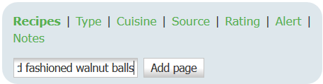
  - Edit the name on the second line if wanted, to add capitalization or dashes or whatever you couldn’t use when adding the page. In this case, I added a dash (-).
﻿{{ :recipes:blank_recipe_card.png?direct&200| }}
====== Old-Fashioned Walnut Balls ======
/* Description */
- Picture
  - Highlight the first line and delete it.
﻿{{ :recipes:blank_recipe_card.png?direct&200| }}
====== Old-Fashioned Walnut Balls ======
/* Description */
  - Leave the cursor on the top line.
  - Click on the picture (green picture in a brown frame)
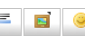
  - Click on “Select Files” button
  - Double-click on the photo you want to use (or select the photo and click on the “Open” button).
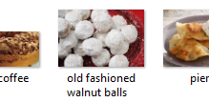
  - Click on the “Upload” button
  - Click on the green file name that you just uploaded
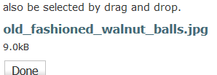
  - Click on the “Insert” button
  - The first line should look like this:
{{ :recipes:old_fashioned_walnut_balls.jpg?direct&200|}}
====== Old-Fashioned Walnut Balls ======
/* Description */

- Description
  - Type a description if you want.
/* Description */
Classic Russian Tea Cakes from Cooks.com
- Cook times
  - Edit the cook times block if you’d like.
<WRAP right>{(rater>id=100|name=Old Fashioned Walnut |**Preheat:** 375°|**Yield:** 4 dozen||
|**Prep:** 0:15|**Wait:** 0:00|**Cook:** 0:15|
- Ingredients
  - Highlight the ingredients in the Word document or web page
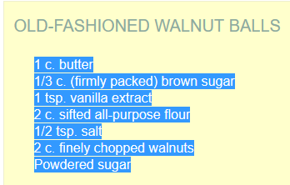
  - Click <Ctrl>C (copy)
  - Click on the line underneath “Ingredients” in the wiki page
  - Click <Ctrl>V (paste)
  - Highlight the ingredient list in the wiki
1 c. butter
1/3 c. (firmly packed) brown sugar
1 tsp. vanilla extract
2 c. sifted all-purpose flour
1/2 tsp. salt
2 c. finely chopped walnuts
Powdered sugar
  - Click on the bullet list button
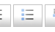
  - The ingredients section should look like this:
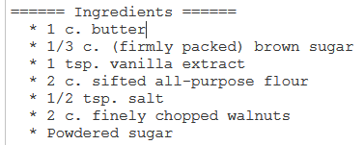

- Directions
  - Highlight the directions in the Word document or web page
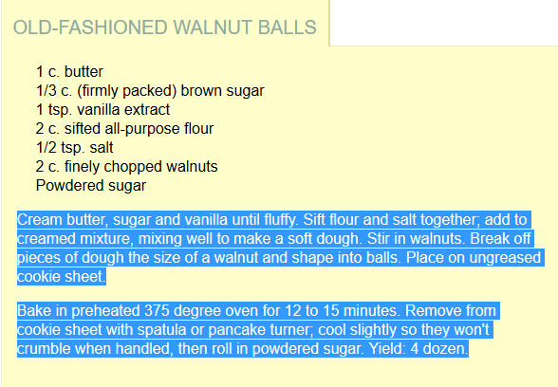
  - Click <Ctrl>C (copy)
  - Click on the line underneath “Directions” in the wiki page
  - Click <Ctrl>V (paste)
  - Highlight the directions list in the wiki
Cream butter, sugar and vanilla until fluffy. Sift flour and salt together; add to creamed mixture, mixing well to make a soft dough. Stir in walnuts. Break off pieces of dough the size of a walnut and shape into balls. Place on ungreased cookie sheet.
Bake in preheated 375 degree oven for 12 to 15 minutes. Remove from cookie sheet with spatula or pancake turner; cool slightly so they won't crumble when handled, then roll in powdered sugar. Yield: 4 dozen.
  - Click on the number list button
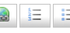
  - The directions section should look like this:
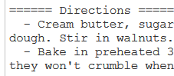

- Notes
  - Add any notes on the recipe that you’d like.
====== Notes ======
* To double recipe, double all the ingredients except the salt; leave salt at 1/2 tsp.
- Tags
  - Scroll to the bottom of the page and highlight the first tag you want.
---Recipe Ratings---
5★
4★
3★
  - Click <Ctrl>C (copy)
  - Go to the next tag you want and put the cursor at the end of the line (including the last space)
  - Click <Ctrl>V (paste)
  - Highlight the line with the tags you just pasted
European/Russian 5★
  - Click <Ctrl>C (copy)
  - Repeat steps c-f for each additional tag
  - When all the tags are in a line and copied, go up to the line that reads:
{{tag>Recipes TagsNeeded}}
  - Delete the word TagsNeeded
  - Click <Ctrl>V (paste)
{{tag>Recipes Dessert/Cookie European/Russian 5★}}
- Click the “Save” button
- Done.

